DESIGN DOCUMENT

By:

Vijaykumar R Pai PES1201702013

Ayush Pratyay PES1201702164

Subham Singh PES1201801830

**GOOGLE OAUTH FLOW DIAGRAM**

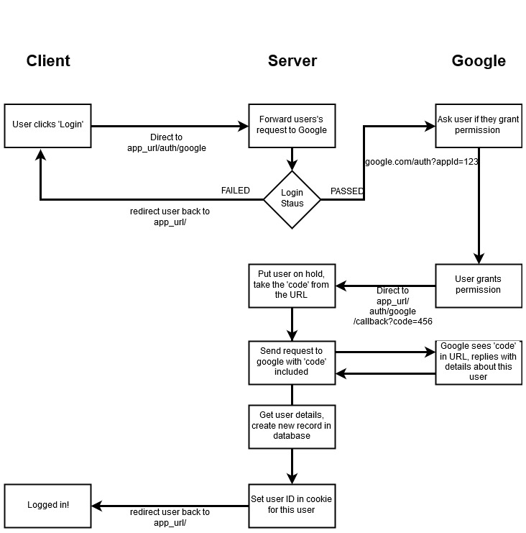

In Google Oauth when the user clicks on the ‘Login’ button, it is redirected to app_url/auth/google and then forwards user’s request to Google. If the login is valid, it will ask the user to grant permission. Once the user grants permission, it is redirected to app_url/auth/google/callback?Code=456. Then it puts user on hold, takes the ‘code’ from the URL. Sends request to google with ‘code’ included. Google sees ‘code’ in URL, replies with details about this user. Therefore, the application gets required user details from the google as it has permission and creates a new record in database. Then it sets userID in cookie for this user and then redirects user back to app_url and later displays on the screen saying the user is now logged in.

**FLOW DIAGRAM OF THE SYSTEM**

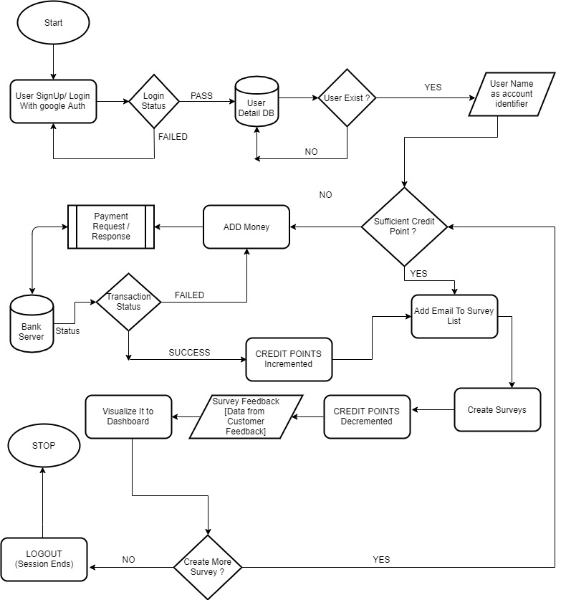

Once the user tries to login using Google Oauth, it validates and checks whether it is valid google user. If it is valid user, his details gets stored to User Detail DB else it is redirected back to login screen saying invalid credentials. If the user already exists, it uses user name as account identifier and checks for sufficient credit points. If there are sufficient points, the user can add email to survey list else the user will have to add money by doing payment through Stripe payment gateway where the user will have to enter his card details and the stripe gateway will check for card verification and if the transaction was successful, it will give transaction status as success else will show as failed. If the transaction was a success, credit points will be incremented and now the user will be able to add email to survey list. Then the user can create surveys. Once a feedback is sent through whether it was in bulk or to a single user, 1 credit point gets decremented. Once the user responds to the feedback form, the reply gets displayed back to the application dashboard where the CRM will be able to see how many responses he has received. Then the user can create more feedbacks or else can logout of the application once the work is done.

**USE CASE DIAGRAM**

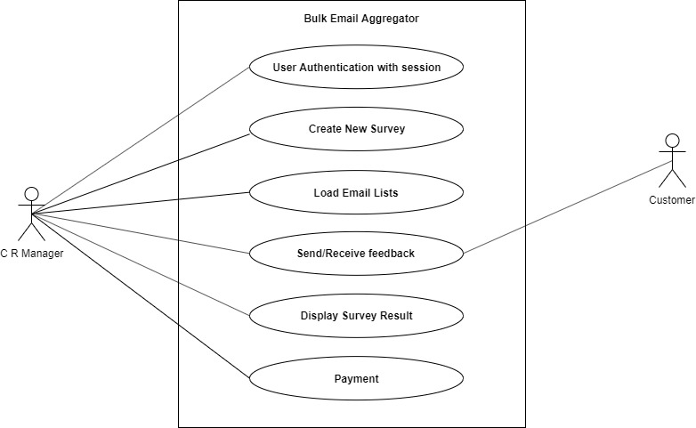

Here the CRM can see the list of users using the application. He can create new feedback forms, load email lists, send/receive feedback, display survey result and number of payments done.

Customer will be receiving feedback and he will be able to respond to it.

**DOCUMENT STRUCTURE**

